**ApiGateway, Lambda, DynamoDB task**

# Description

In this module we will take a look on ApiGateway, take a look on Serverless computing and try some things with NoSQL Serverless Native DynamoDB.

**Diagram**

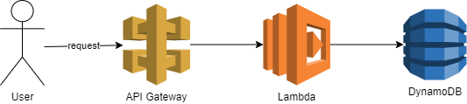

# Homework

At the end of this homework you need to have:

API Gateway with two endpoints to upload information about your products (id, name, pictureURL, price) and to update information

Lambda that processes that upload (check if data is already present in DynamoDB and put it if it is not present)

Lambda that processes information updates

DynamoDB with 1 Table with products information

Create DynamoDB table for products info (be sure to [read](https://docs.aws.amazon.com/amazondynamodb/latest/developerguide/bp-query-scan.html)) :

NOTE: product is some simple model with name, price and picture_url

    20 points

Implement Lambda that processes uploading information about products from request body (be sure, that lambda uses assume role instead of raw credentials to access DynamoDB):

    20 points

Implement Lambda that processes updating information about products (be sure, that lambda uses assume role instead of raw credentials to access DynamoDB):

    20 points

Create API gateway and configure endpoints:

    20 points

Implement small console application with generated API gateway sdk ([link](https://docs.aws.amazon.com/apigateway/latest/developerguide/how-to-call-apigateway-generated-java-sdk.html)) to create and update information:

    20 points

**Extra mile:**

Implement simple js application with generated API gateway sdk for uploading information

Total mark is 100.